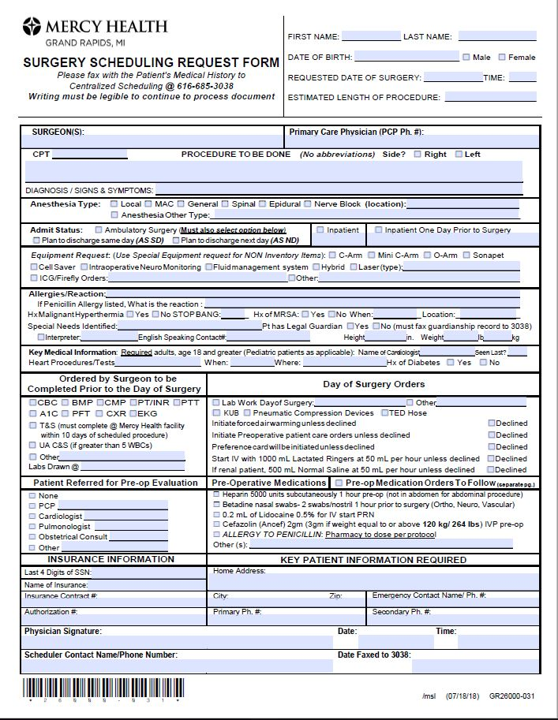
↑ Day of Surgery Orders: This is the only place to document day of surgery labs/orders otherwise they will be missed.

↓ Admit Status: If ambulatory surgery patient MUST also select either:
1. Plan to discharge Same Day OR
2. Plan to discharge next day)

We no longer will use Extended Stay Recovery as an Admit Type
↑ Legal Guardian: will only accept current guardianship paperwork.
↑ Pre-operative Medications Orders to Follow: Must check this box when sending a second page of Day of Surgery Medication Orders! Staff use this as their ALERT to anticipate the 2nd page of medication orders.
This is the only place to document Pre-operative Medication Orders otherwise they will be missed.
↑ Equipment Requests: More options to select. Added ICG/Firefly orders.
This is the only place to document equipment requests otherwise they will be missed.
↓ Anesthesia Type:
Nerve Block (location): include name of block
Examples: ☒ Nerve Block Axillary Block
Added Anesthesia Other Type:_____
↑ Insurance Information: Only last 4 numbers of SSN.

